Group Activity 6b; CS 3060

Names of students in your group:
Points: 10
Goal: To make us familiar with Scala’s support for parallel computation. In particular, we will become familiar with the map-reduce style computation as available in Scala.

Task 1: (3 points) Consider the following Scala code, which is supposed to compute the SUM of the cubes of integers from 1 to 10, involving parallel execution. Fill in the blanks to complete the code. Hint: Refer to examples given on Slide 41-44 on Scala ppt 3.

L1. val list1 = // make a list of 1 to 10

L2. val list2 = // make a par version of the list

L3. val list3 = list2.map(x => ) // get list of cubes

L4. println(list3.reduce ) // compute and print the prod

map
1*1*1
2*2*2
3*3*3
.. …..
……
.. ….
n*n*n
reduce
op
with *
1
2
3
..
..
n
final
result

map step runs in parallel

Task 2: (4 points) Say you are given a list of urls. First, you will get the corresponding webpages (which are nothing but strings). Then, compute the total number of links present in those webpages. Do the above in two ways: in serial fashion and parallel fashion. Compare serial and parallel execution time. Figure 1 and Figure 2 below show the schematic diagram of the serial and parallel computation.

Hint: to define a regex for a link and to count the num of matches, you may refer to Slide 17 in ppt 3.

More help: On Scala ppt 3 Slide 31 we have code to compare serial and parallel execution time of computing the size of multiple webpages. Also, on Scala ppt 3 Slide 44 we have code to compute sum of the size of multiple webpages in parallel fashion. Tweak these code snippets to do Task 2.

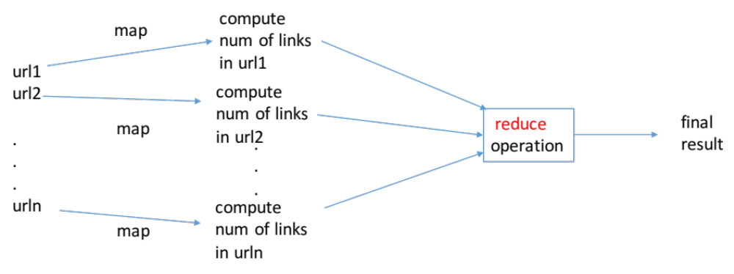
Figure 1: Computation with regular collection (e.g., a list). All operations run serially.

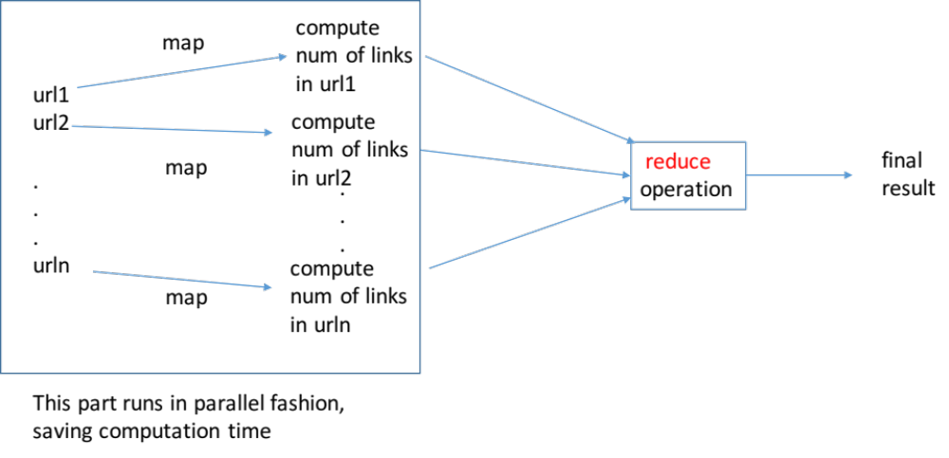
Figure 2: Computation with Parallel collection (e.g., list.par). The map part runs in parallel fashion.

